|  |  |
| --- | --- |
| Date | 12 October 2022 |
| Project name | Global sales data Analytics |
| Team ID | PNT2022TMID45267 |

*Country wise sales using map points*

*Data visualization:*

*It is a process of creating a representation of data that is not just textual or numeric but also intuitive and easy to understand. Data Visualization allows the audience to see a large set of information at one glance. And it makes decisions based on what they see quickly.*

*1.Facebook likes map: A Facebook map can be made using the data from your Facebook account. This includes personal information, location tracking, and even your interests. You can use this data to create a visual representation of where you live and how you feel about it by using a map or simply listing what you like from A-Z.*

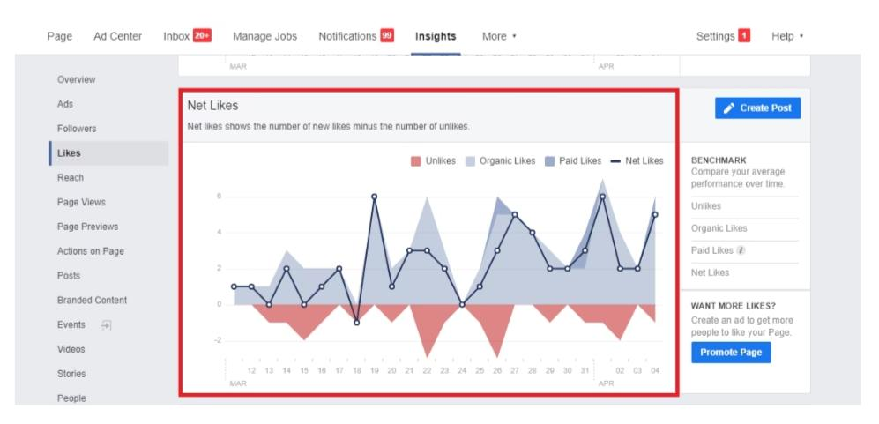

*2.Spotify music map:*

*Spotify is a music streaming service. It has gained more than 140 million active users. The company possesses a data visualizing tool called Music Map. This tool helps you explore music popularity by showing you which songs are most popular in different countries. You can also filter this information by genre and year, or even see how tracks are trending on certain days of the week.*

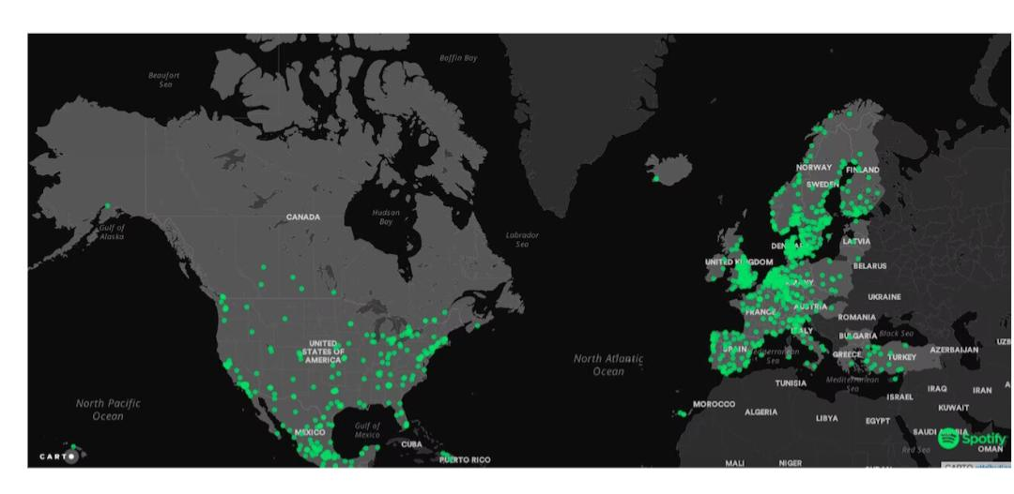

*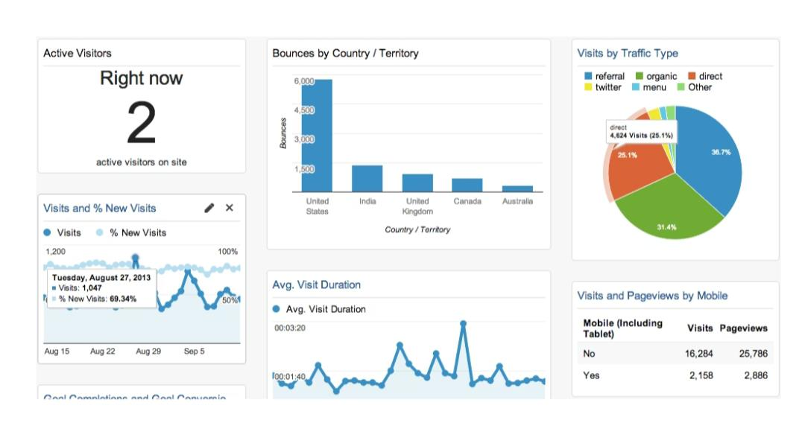3 . Google analytics dashboard:*

*Google Analytics Dashboard is a free web analytics tool that provides you with detailed statistics about your website traffic, including which parts of your website are most popular and how long visitors stay on each page.*

*4.Water consumption:*

*Water consumption is a topic that may not be immediately obvious, but it’s important to understand how much water we use as a country and what we use it for. This can help us better manage our resources and improve our communities by using them more efficiently. Here are some common questions about water consumption.*

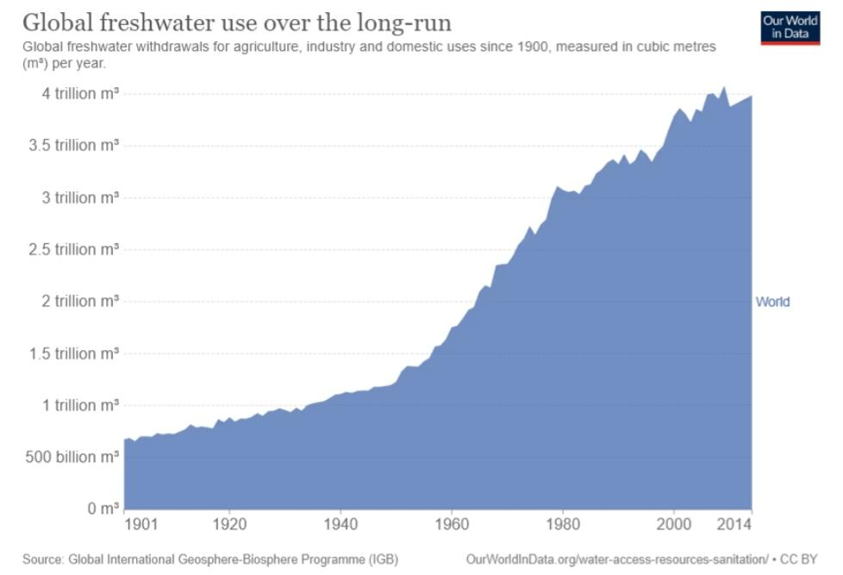

*5.mental health user experience journey:*

*As you can see, mental health is a serious issue that affects people all over the world. Too often, it goes undiscussed and misunderstood for lack of education about its nuances and complexities.*

*Whether you’re looking for ways to help someone who has struggled with mental illness or want to learn more about the condition yourself, this data visualization tool provides an excellent starting point.*

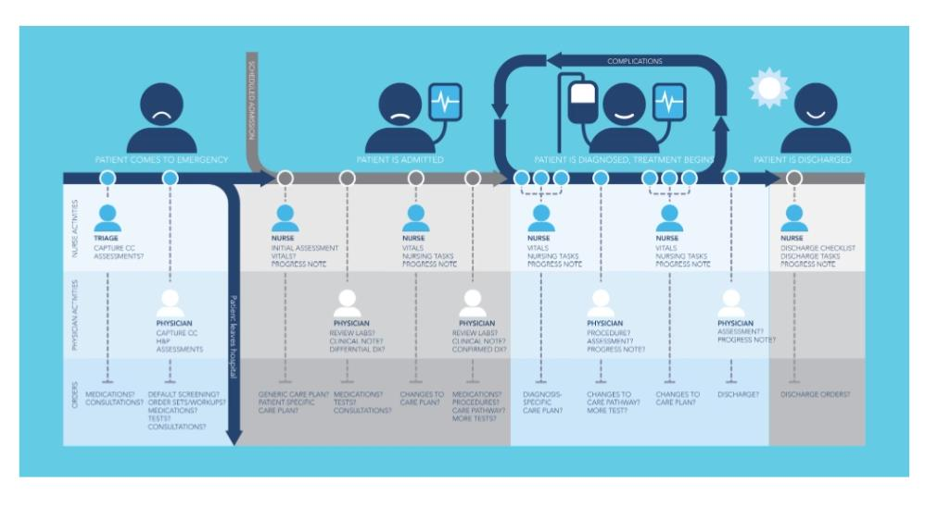

*6.microsoft power Bi data visualization example data:*

*Power BI is a cloud-based business analytics service. It allows users to create interactive visualizations, dashboards, and reports from their organization’s database. The platform also allows users to publish to the web and share reports with others outside of the organization.*

